Nicole –

Nice write-up.

You provide excellent background and rationale for your project.

I think I understand what your objective is, but you need to clarify it: ‘analyzing a data set’ is not a research objective ☺ Be clear about specifically what you are testing. For example: Does diet composition of sea otters differ by age, sex and between regions that have been occupied by sea otters for different periods of time”.

The data description is OK, but too much focus on the matlab program. The important part is to clearly define your unit for analysis (269 bouts/otters). See comments below [- 1 point]

**Title:** Sea otter diet composition with respect to recolonization and demography in southern Southeast Alaska

**Background:** Sea otters, unlike most marine mammals, do not have blubber to keep them warm in the marine environment. Instead, sea otters maintain very high metabolisms; consuming up to 25% of their body weight in food per day to sustain these elevated metabolic costs (Costa and Kooyman 1982). Because of their voracious appetites, sea otters have large effects on the nearshore marine ecosystem in a relatively short time period, often referred to as a keystone predator (Estes and Palmisano 1974, Paine 1980). The islands around Southeast and Southcentral Alaska that sustain sea otter populations are mostly soft and mixed sediment habitats (Kvitek and Oliver 1992, Kvitek et al. 1993, Wolt et al. 2012, Weitzman 2013). In soft and mixed sediment locations, sea otters have clam-dominated diets (Kvitek and Oliver 1992, Kvitek et al. 1993, Wolt et al. 2012, Weitzman 2013). Although the diet is dominated by clams, over 100 invertebrate and fish species have been documented as sea otter prey in soft and mixed sediment habitats (Newsome et al. 2015).

For over 100 years while sea otters were absent from Southeast Alaska, the nearshore ecosystem lacked a keystone predator, allowing populations of commercially valuable organisms such as geoduck (*Panopea generosa*), red sea urchin (*S. franciscanus*), Dungeness crab (*Metacarcinus magister*), and sea cucumber (*Apostichopus californicus*) to flourish (Pritchett and Hoyt 2008, Larson et al. 2013, Hoyt 2015). Previous studies have shown reduced biomass of preferred prey once sea otters have recolonized (Larson et al. 2013, Hoyt 2015). The vicinity including Prince of Wales Island (POW) in southern Southeast Alaska has two original release locations and has commercial fishing zones for shellfish. Hoyt (2015) studied sea otter diets around POW for three seasons (2010-2012) focusing on sea otter impacts on commercially important species. Hoyt (2015) found that the number of species consumed by sea otters increases as time since recolonization increases, and abundance of commercially important species was reduced where sea otters were present vs. absent. An example of commercial shellfishery impact by sea otters is the red urchin fishery. Once sea otters recolonized the western side of POW, sea urchin dive fisheries were closed due to low urchin numbers in ADFG dive surveys (Pritchett and Hoyt 2008).

Sea otters can be used as a looking glass into the overall ecosystem because of their foraging habits. Sea otters sample benthic invertebrates at a high rate and with better skill than people can attain with SCUBA surveys (Riedman and Estes 1990, Oftedal et al. 2007). Wide-ranging studies of sea otter diets can aid in the management of commercially important and subsistence species in Southeast Alaska, while co-managing for a protected apex predator. Better understanding differences in prey across sea otter demographics can help with relation to newly inhabited zones dependent on the recolonization patterns of sea otters.

**Problem description:** I would like to analyze this visual foraging sea otter dataset with respect to potential regional (time-since-recolonization) and demographic (age, sex) differences in diet.

**Data:** The base dataset consists of 3,372 forage dives for 362 individual sea otters. Data were collected on the western side of POW Island over 8 foraging sites (Figure 1) from May – August, 2018. Based on estimated prey size and known length-weight relationship, consumption (grams/minute) was estimated for each foraging bout that consisted of five or more dives (269 dives). A Monte Carlo resampling algorithm was used to estimate unknown prey based on other prey observed in the study area (Tinker et al. 2008). The resulting data matrix consisted of the estimated consumption rate (grams/minute) by prey class. For each bout, the sex and age of the otter and the date, location, and success rate (% of dives that resulted in at least one prey item) were recorded. Location for each bout was collected in latitude and longitude, time since recolonization from USFWS aerial surveys, and foraging zones, along with sea otter sex, pup size (if present), age class, tool use, and environmental variables (weather conditions).

**Data checking and preliminary exploratory analysis:** The data set included 91 females, 58 males, and 120 unknown sex. There were 180 adults, 22 juveniles, and 67 otters of unknown age. 46 bouts occurred in an area that was recolonized prior to 1988; 184 bouts from the middle recolonization zone (19882003); and 39 bouts from the most recent recolonization zone (after 2010) (Figure 2).

Overall, sea otters around Prince of Wales consumed about 69% clam species by biomass (Figure 3).

**Potential issues:** The data for each prey class is not normally distributed (Figure 4). This is because clams are such a large proportion of the diet (Figure 3), and otters tend to forage on one particular species during a bout. I do not know if I need to transform the data before analyzing.

General recommendations:

1. Following a fairly standard approach for these type of data, I suggest a square-root transformation, with no standardization (to emphasize species that have a higher consumption rate in terms of biomass).
2. Visualize (dis)similarities in prey composition using NMDS and highlight different groups (time since recolonization, age, sex).
3. Perform a permutation-based ANOVA to partition variability among groups (adonis/adonis2)
4. You could include additional environmental variables to account for possible environmental effects on diet composition. Different locations (the 8 regions or finer scale) will almost certainly differ as well (in addition to differences among the 3 recolonization groups, but that would require a mixed-effects approach. There may be a latitudinal gradient (?) but that may also be confounded with recolonization.

You can more or less follow the template in module 15

References:

Costa, D. P., and G. L. Kooyman. 1982. Oxygen consumption, thermoregulation, and the effect of fur oiling and washing on the sea otter, *Enhydra lutris*. Canadian Journal of Zoology 60:2761–2767.

Estes, J. A., and J. F. Palmisano. 1974. Sea otters: Their role in structuring nearshore communities. Science 185:1058–1060.

Hoyt, Z. N. 2015. Resource competition, space use and forage ecology of sea otters, *Enhydra lutris*, in southern Southeast Alaska. University of Alaska, Fairbanks, Alaska, USA.

Kvitek, R. G., C. E. Bowlby, and M. Staedler. 1993. Diet and foraging behavior of sea otters in Southeast Alaska. Marine Mammal Science 9:168–181.

Kvitek, R. G., and J. S. Oliver. 1992. Influence of sea otters on soft-bottom prey communities in Southeast Alaska. Marine Ecology Progress Series 82:103–113.

Larson, S. D., Z. N. Hoyt, G. L. Eckert, and V. A. Gill. 2013. Impacts of sea otter (*Enhydra lutris*) predation on commercially important sea cucumbers (*Parastichopus californicus*) in Southeast Alaska. Canadian Journal of Fisheries and Aquatic Sciences 70:1498–1507.

Newsome, S. D., M. T. Tinker, V. A. Gill, Z. N. Hoyt, A. Doroff, L. Nichol, and J. L. Bodkin. 2015. The interaction of intraspecific competition and habitat on individual diet specialization: a near range-wide examination of sea otters. Oecologia 178:45–59.

Oftedal, O. T., K. Ralls, M. T. Tinker, and A. Green. 2007. Nutritional constraints on the southern sea otter in the Monterey Bay National Marine Sanctuary. Page Joint Final Report to Monterey Bay National Marine Sanctuary (and Monterey Bay Sanctuary Foundation) and the Marine Mammal Commission.

Paine, R. T. 1980. Food webs: Linkage, interaction strength and community infrastructure. The Journal of Animal Ecology 49:666.

Pritchett, M., and Z. N. Hoyt. 2008. Report to the Board of Fisheries, miscellaneous dive fisheries.

Riedman, M., and J. A. Estes. 1990. The sea otter (*Enhydra lutris*): behavior, ecology, and natural history. US Fish and Wildlife Service Biological Report 90:1–126.

Tinker, M. T., G. B. Bentall, and J. A. Estes. 2008. Food limitation leads to behavioral diversification and dietary specialization in sea otters. Proceedings of the National Academy of Sciences of the United States of America 105:560–565.

Weitzman, B. P. 2013. Effects of sea otter colonization on soft-sediment intertidal prey assemblages in Glacier Bay, Alaska. University of California, Santa Cruz.

Wolt, R. C., F. P. Gelwick, F. Weltz, and R. W. Davis. 2012. Foraging behavior and prey of sea otters in a soft- and mixed-sediment benthos in Alaska. Mammalian Biology 77:271–280.

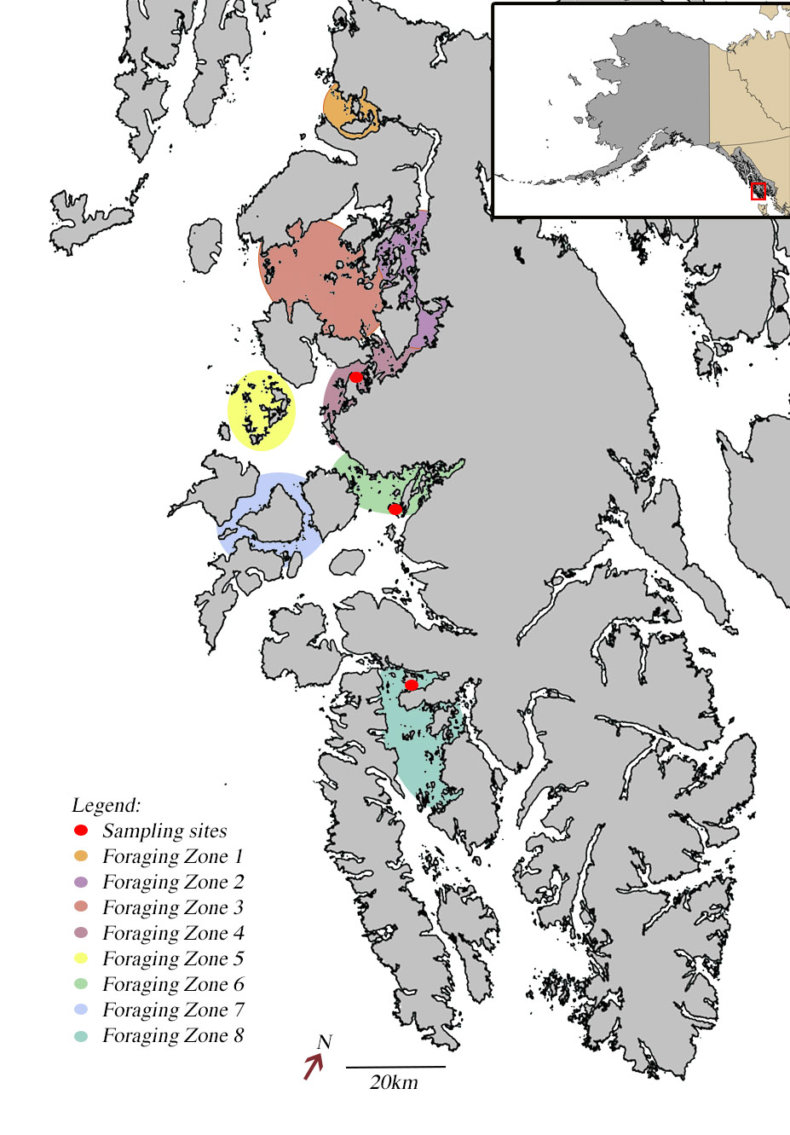

Figure 1: Map of Prince of Wales Island, Southeast Alaska. Colored polygons indicate foraging data collection zones, which coordinate with Alaska Department of Fish and Game sea otter surveys and the year sea otters were first seen. Red circles indicate invertebrate sampling sites (not a part of this project directly).

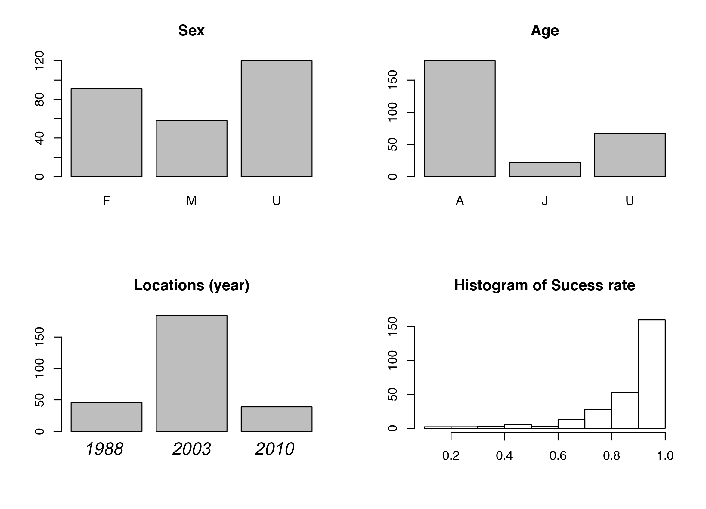Figure 2: Basic information about the sea otter visual foraging dataset. There are 269 individual otters (bouts) with 91 females, 58 males, and 120 unknown sex. There are 180 adults, 22 juveniles, and 67 unknown age. There are 46 bouts from the oldest recolonization zone, 1988; 184 bouts from the middle recolonization zone, 2003; and 39 bouts from the newest recolonization zone, 2010. The last graph is of a histogram of the count of success rate for sea otters across all 269 bouts.



Figure 3: Overall sea otter diet composition for all dives collected in 2018 by prey class (x-axis). Diet is proportion of the diet by biomass. Error bars show one standard deviation from estimated biomass percentage.



Figure 4: Distribution of sea otter prey in grams per minute in the diet. Each pray class is separated, showing that a majority of the prey classes don’t have a normal distribution.